**MULTIUSE COLLEGE APPLICATION**

**A PROJECT REPORT**

***Submitted by***

**JOTHI PRAKASAM W**

**CSE -III YEAR**

**VELAMMAL INSTITUTE OF TECHNOLOGY**

**CHENNAI-600028**

**ABSTRACT**

The Multiuse College Application project is an Android based application designed to cater to the needs of the students and College Management. The platform offers a comprehensive suite of features that enable users to track, analyze, and make informed decisions about their college. At the heart of the application is its real-time database functionality, which provides users with up-to-date information on placement activities,Lecturer Notes and Videos,Notice,Faculty details,Gallery about events,etc., This real-time data empowers users to monitor College data, identify updated notice. To personalize the user experience, the Multiuse College Application project offers Android Application. Admin can create and customize their data by using Google Firebase. They can effortlessly handle the performance and value of their data, gaining valuable insights into their data . One of the standout features of the Multiuse College application project is its advanced Notification System. Users can get personalized notification alerts for specific events, ensuring they never miss out on significant messages. The platform sends timely notifications to users' preferred communication channels, allowing them to take prompt action based on their predefined thresholds. To provide users with a comprehensive view of the Multiuse college landscape, the application integrates College Management and College student. Users can access the latest college articles,staff notice, and Result insights, enabling them to stay informed about College developments and make well-informed Management decisions. The Multiuse College Application project takes pride in its user-friendly interface, which offers intuitive navigation, visually appealing interface, and interactive tools. The platform strives to deliver a seamless user experience, making it easy for both admin and experienced users to access and interpret the data. In summary, the Multiuse College Application project is an innovative Android-based application that equips users with real-time tracking, personalized college management, Notification alerts, and comprehensive Result information. By offering a user-friendly interface and empowering users to make data-driven decisions, the project aims to enhance the overall College Management data and enable users to navigate the communication with college management with confidence.

**TABLE OF CONTENTS**

|  |  |  |
| --- | --- | --- |
| **CHAPTER NO** | **TITLE** | **PAGE NO** |
|  | ABSTRACT | I |
| 1 | INTRODUCTION | 4 |
| 2 | LITERATURE SURVEY | 5 |
| 3 | SYSTEM ANALYSIS | 7 |
| 3.1 | EXISTING SYSTEM | 7 |
| 3.2 | PROPOSED SYSTEM | 7 |
| 4 | SYSTEM REQUIREMENTS | 8 |
| 4.1 | HARDWARE REQUIREMENTS | 8 |
| 4.2 | SOFTWARE REQUIREMENTS | 8 |
| 5 | SYSTEM DESIGN | 9 |
| 5.1 | DATAFOW DIAGRAM | 9 |
| 5.2 | USECASE DIAGRAM | 10 |
| 6 | SYSTEM IMPLEMENTATION | 11 |
| 6.1 | HOME MODULE | 11 |
| 6.2 | NOTICE MODULE | 11 |
| 6.3 | FACULTY MODULE | 11 |
| 6.4 | GALLERY MODULE | 11 |
| 6.5 | ABOUT MODULE | 11 |
| 6.6 | EBOOKS MODULE | 11 |
| 6.7 | VIDEO LECTURES MODULE | 12 |
| 6.8 | WEBSITE MODULE | 12 |
| 6.9 | SHARE MODULE | 12 |
| 7 | CONCLUSIONS AND FUTURE WORK | 13 |
| 7.1 | CONCLUSIONS | 13 |
| 7.2 | FUTURE WORK | 13 |
| 8 | SNAPSHOTS | 15 |
| 9 | REFERENCES | 25 |
|  |  |  |

**CHAPTER 1**

**INTRODUCTION**

Introduction : The Multiuse College Application project is an Android based application designed to cater to the needs of the students and College Management. The platform offers a comprehensive suite of features that enable users to track, analyze, and make informed decisions about their college. At the heart of the application is its real-time database functionality, which provides users with up-to-date information on placement activities,Lecturer Notes and Videos,Notice,Faculty details,Gallery about events,etc., This real-time data empowers users to monitor College data, identify updated notice. To personalize the user experience, the Multiuse College Application project offers Android Application. Admin can create and customize their data by using Google Firebase. They can effortlessly handle the performance and value of their data, gaining valuable insights into their data . One of the standout features of the Multiuse College application project is its advanced Notification System. Users can get personalized notification alerts for specific events, ensuring they never miss out on significant messages. The platform sends timely notifications to users' preferred communication channels, allowing them to take prompt action based on their predefined thresholds. To provide users with a comprehensive view of the Multiuse college landscape, the application integrates College Management and College student. Users can access the latest college articles,staff notice, and Result insights, enabling them to stay informed about College developments and make well-informed Management decisions. The Multiuse College Application project takes pride in its user-friendly interface, which offers intuitive navigation, visually appealing interface, and interactive tools. The platform strives to deliver a seamless user experience, making it easy for both admin and experienced users to access and interpret the data. In summary, the Multiuse College Application project is an innovative Android-based application that equips users with real-time tracking, personalized college management, Notification alerts, and comprehensive Result information. By offering a user-friendly interface and empowering users to make data-driven decisions, the project aims to enhance the overall College Management data and enable users to navigate the communication with college management with confidence.

**CHAPTER 2**

**LITERATURE SURVEY**

The literature survey for the Multiuse College Application project involves exploring relevant research, studies, and publications related to college management, real-time data analysis, and user experience design. The purpose of this survey is to gather insights, establish a knowledge base, identify research gaps, and support the objectives of the project.

**Muliuse college application Market Analysis:**

* Research on real-time college data aggregation and analysis techniques.
* Studies on college management , study trends, and historical performance.
* Analysis of different approaches to collecting and processing student data.

**Multiuse college application Portfolio Management:**

* Literature on portfolio management strategies in the context of College data.
* Research on risk assessment and diversification techniques for college portfolios.
* Studies on performance evaluation and optimization of college portfolios.

**User Experience Design for Educational Applications:**

* Research on user interface design principles and best practices for educational applications.
* Studies on user interaction and engagement in study and educational platforms.
* Analysis of usability testing methods and user-centered design approaches.

**Multiuse college application Notifiation and Market Analysis:**

* Literature on integrating notification feeds and market analysis into educational applications.
* Research on sentiment analysis and the impact of data on educational sector.
* Studies on the correlation between student and college management.

**Security and Privacy in Multiuse college Application:**

* Research on security measures and encryption techniques in educational applications.
* Studies on privacy concerns and data protection in educational platforms.
* Analysis of best practices for securing user data and transactions in educational applications.

**Emerging Trends and Future Directions:**

* Exploration of emerging technologies and trends in the education sector.
* Studies on the integration of android technology into educational applications.
* It is important to review scholarly articles, research papers, conference proceedings, and reputable industry reports from sources such as academic databases, educational journals, and education research organizations. The literature survey should cover a wide range of sources to ensure a comprehensive understanding of the relevant topics and provide a solid foundation for the Multiuse College Application project.

The findings from the literature survey should be synthesized, and relevant references and citations should be incorporated into the project report to support the statements, recommendations, and conclusions presented in the document. The survey contributes to the overall credibility and depth of the project report, demonstrating a well-informed and research-backed approach to the development of the Multiuse College application.

**CHAPTER 3**

**SYSTEM ANALYSIS**

**3.1 EXISTING SYSTEM**

In the existing system of educational applications, there are several platforms and applications available that allow users to monitor and track educational activities. These systems provide real-time data on result,time table,notes and other relevant information. Some popular examples Stucor,padeepz,etc.,

**3.2 PROPOSED SYSTEM**

The proposed Multiuse College Application is a comprehensive platform that combines personalized college management, real-time notice sharing, advanced alerts, events and result analysis, route tracking, a user-friendly interface, and robust security measures. Users can easily create and manage their profile, monitor real-time college data, access advanced analytics for informed decision-making, stay updated with curated news and market analysis, track their activities, and enjoy a seamless user experience across web and mobile platforms. The system emphasizes simplicity, visual clarity, and mobile compatibility, providing users with powerful tools to effectively manage their student data. With a focus on security, encryption, and secure authentication protocols, the system ensures the protection of user data and assets. It aims to empower users by providing them with the necessary tools and information to navigate the dynamic education communication with confidence.

**CHAPTER 4**

**SYSTEM REQUIREMENTS**

* 1. **HARDWARE REQUIREMENTS**
     + - Hard Disk : 500GB and Above
       - RAM : 8GB and Above
       - Processor : I3 and Above

### SOFTWARE REQUIREMENTS

* Operating System : Windows 7, 8, 10 ,11(64 bit)
* Tools : Android Studio
* Programming Language : Java
* Storage : Google Firebase
* Application Widgets : Youtube, Google Maps,Google Drive

**CHAPTER 5**

**SYSTEM DESIGN**

* 1. **DATA FLOW DIAGRAM:**

GOOGLE

FIREBASE

USER

ADMIN

**Data flow diagra**

* 1. **USECASE DIAGRAMS:**

**USECASE DIAGRAM FOR PROJECT MODULE:**



**USECASE DIAGRAM FOR USAGE OF AN APPLICATION:**



**CHAPTER 6**

**SYSTEM IMPLEMENTATION**

**6.1 Home Module**

The Home module allows users to access College contact on Multiuse College Application.Users are getting about their college information such as Address, email address, and phone number. The system takes the user into Gmap for Route from their boarding point.

**6.2 Notice Module**

The alerts and notifications module allows users to set personalized alerts for specific events.

It consists of notice along with updation date and time.

**6.3 Faculty Module**

In this module, users can search for Faculty profile,about their mail id and contact number.

**6.4 Gallery Module**

In this module,user can able to view about their college various events and belonging photo gallery

**6.5 About Module**

In this module, users can access about the college infrastructure,library,labs,On-campus hostel for boys and girls.

**6.6 Ebooks Module**

The Ebook module allows users to access their lecturer notes on pdf format.

**6.7 Video Lectures Module**

The Video Lecturer module enables users to customize their faculty lecturer videos on the Multiuse College Application platform.

**6.8 Website Module**

The website module enables the user to access the college official website.

**6.9 Share Module**

In this module,user can share our application to their friends,parents and their needed persons.

**CHAPTER 7**

**CONCLUSIONS AND FUTURE WORK**

**7.1 Conclusions**

In conclusion, the Multiuse College application has successfully developed a comprehensive platform that enables users to monitor and manage their college record effectively. The system implementation covers key modules such as registration, profile management, result tracking, alerts and notifications, news and analysis, exchange integration, and settings and preferences. These modules provide users with real-time student data, personalized alerts, curated news, and a seamless user experience.

Through the implementation of these modules, the Multiuse College Application platform aims to empower users with the tools and information necessary to make informed educational decisions. By tracking their data , users can assess their overall performance, analyze educational trends, and identify potential opportunities.

The alerts and notifications feature keeps users updated on communication between the student and the College management and ensures they never miss important notifications or significant updates .

**7.2 Future Work**

While the current system implementation provides a strong foundation for a education platform, there are several areas of future work that can enhance its functionality and user experience:

* Enhanced Security: Continuous improvements in security measures, such as two-factor authentication and encryption, can be implemented to ensure the safety of user data.
* Advanced Analysis Tools: Incorporating advanced data analytics and visualization techniques can provide users with more in-depth insights into education trends and patterns, facilitating more informed decision-making.
* Mobile Application Development: Developing a mobile application would enhance accessibility and convenience, allowing users to track their activities on-the-go and receive instant notifications.
* Multi-Language Support: Adding support for multiple languages would enable users from different regions to access and utilize the platform in their preferred language, increasing its global reach and usability.
* Portfolio Analysis and Recommendations: Implementing advanced algorithms and machine learning techniques can provide users with personalized portfolio analysis and investment recommendations based on their risk tolerance.

By incorporating these enhancements and continuously improving the platform based on user feedback, the Multiuse College application project can evolve into a robust and comprehensive tool for college management, empowering them to navigate the dynamic world of education communication with confidence.

In conclusion, the cryptocurrency tracker project has made significant strides in providing users with a user-friendly and feature-rich platform for managing their cryptocurrency investments. With ongoing improvements and future enhancements, the project has the potential to further revolutionize the way users engage with cryptocurrencies and make informed investment decisions.

**CHAPTER 8**

**SNAPSHOTS**

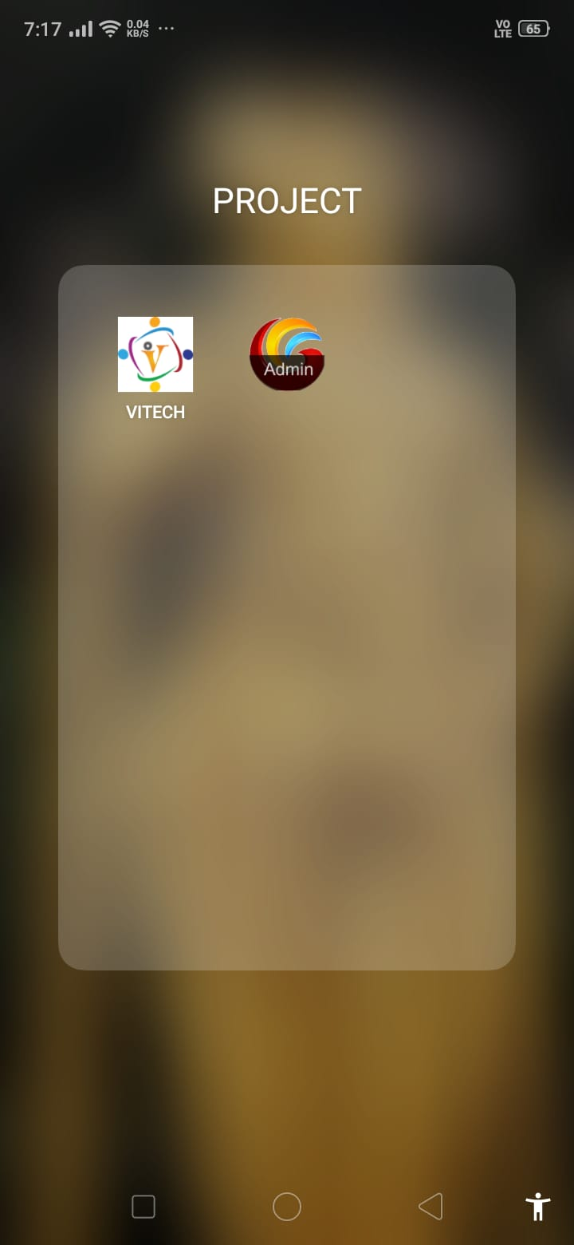

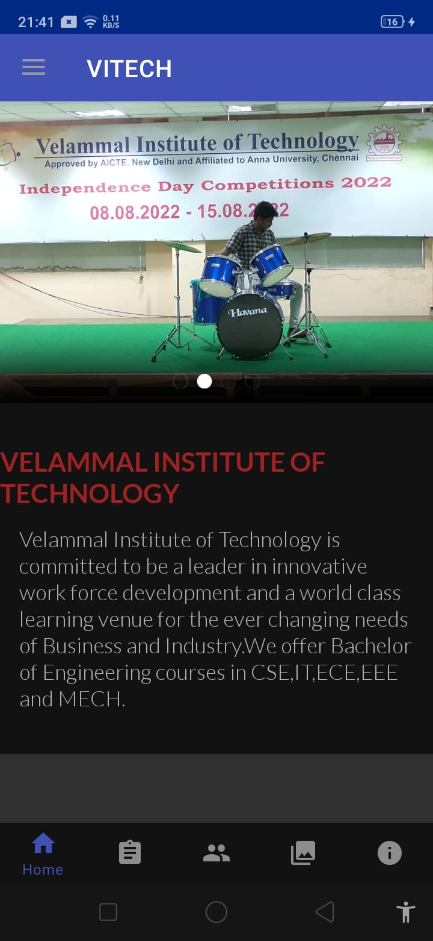

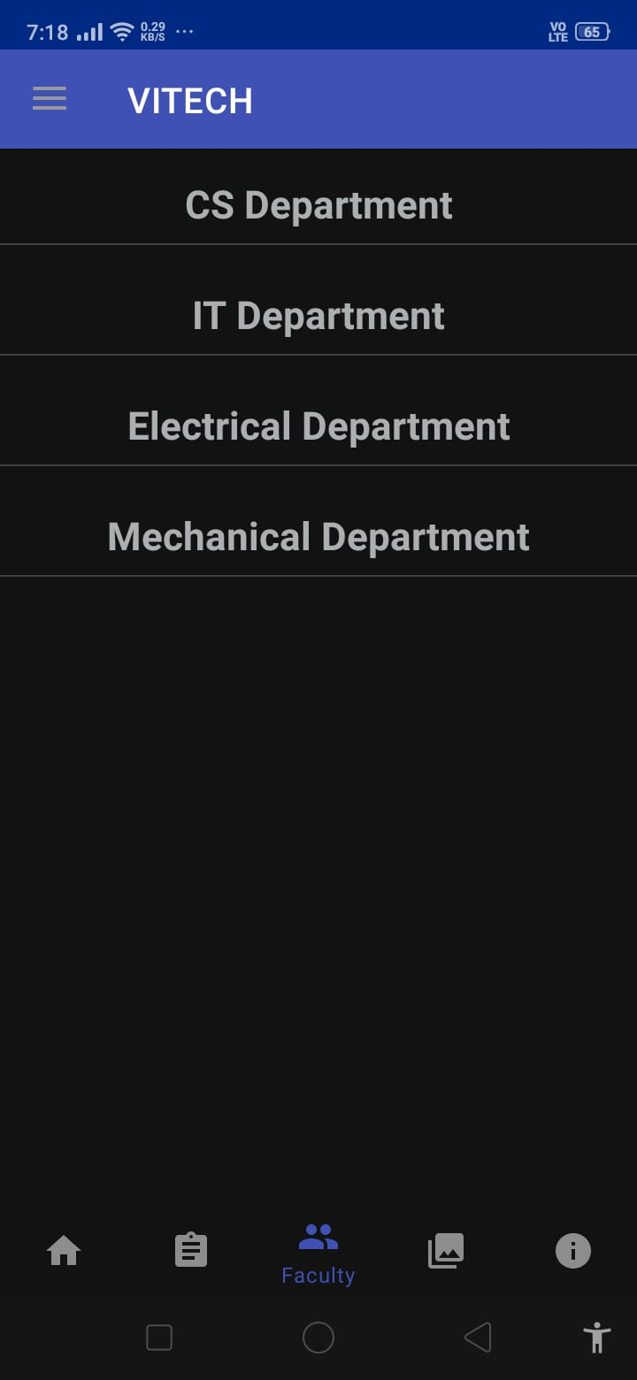

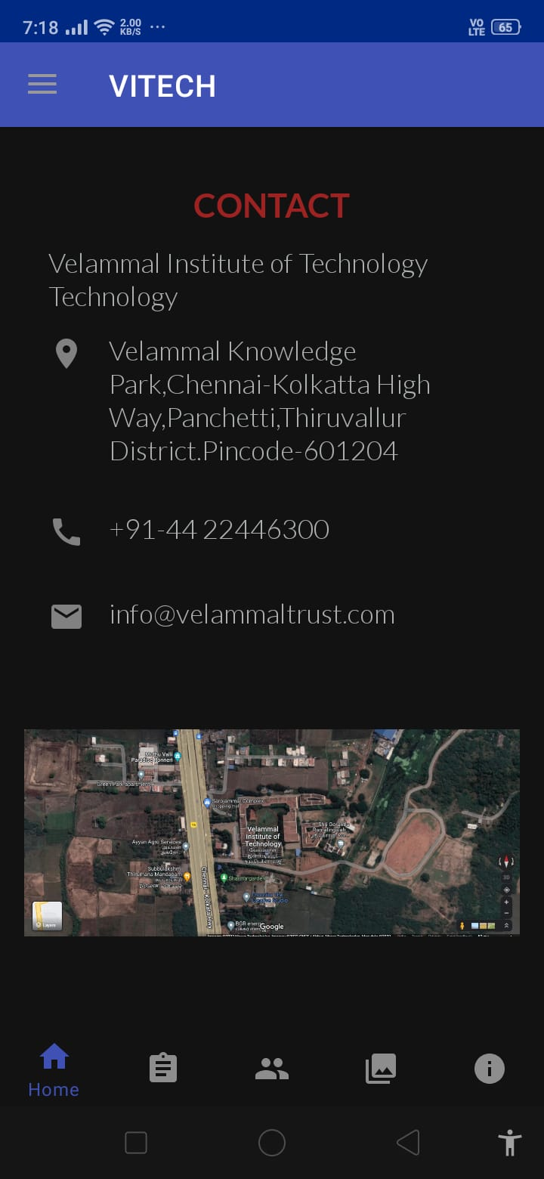

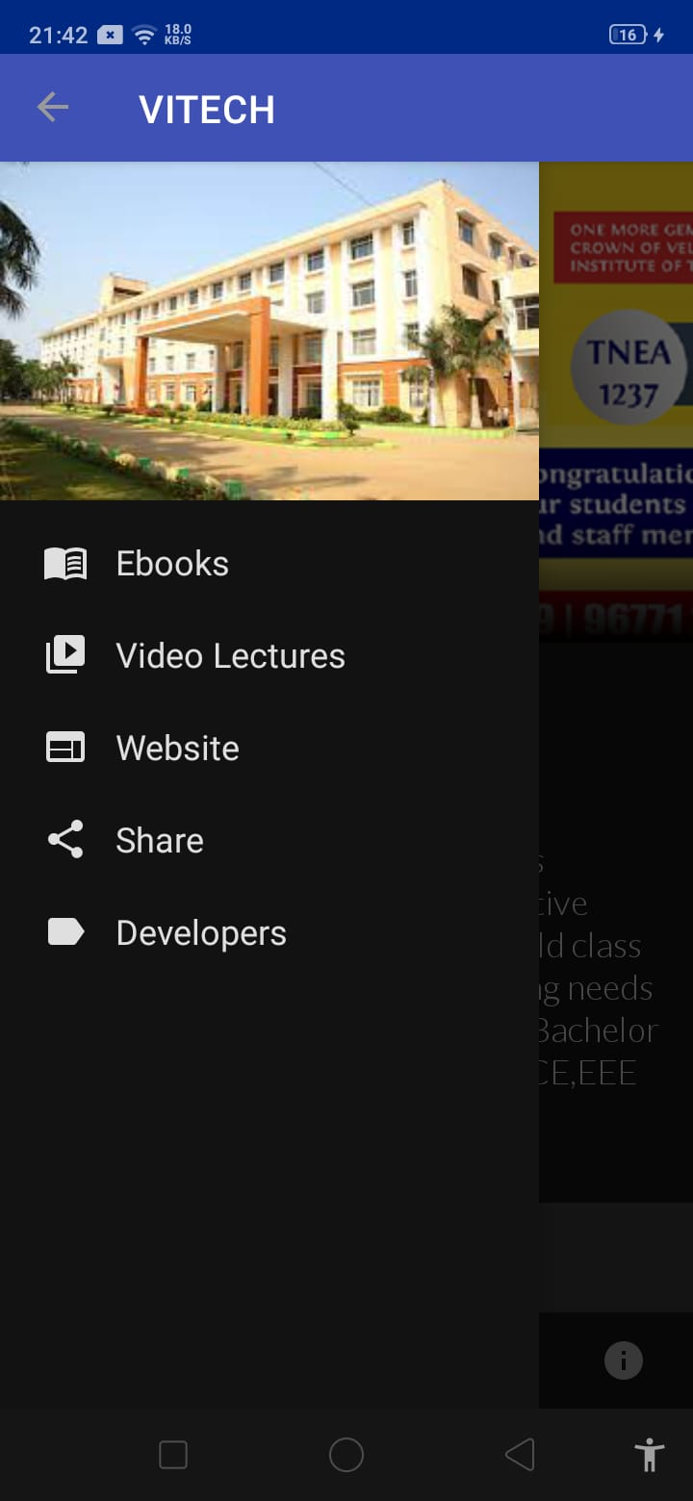

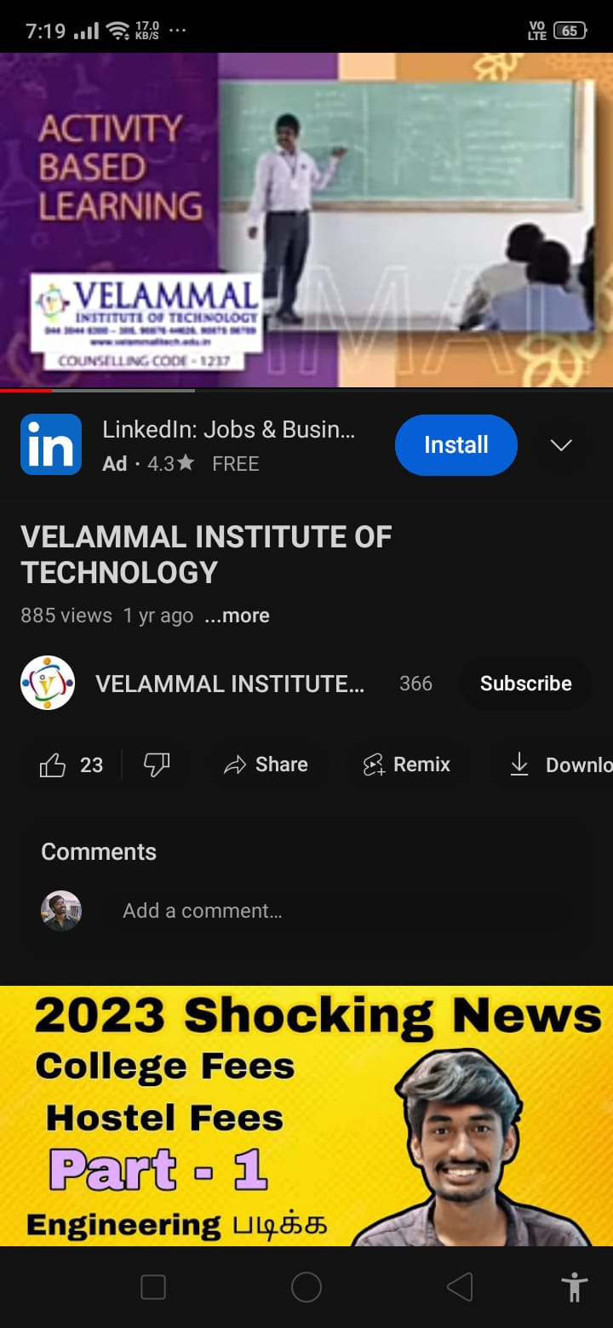

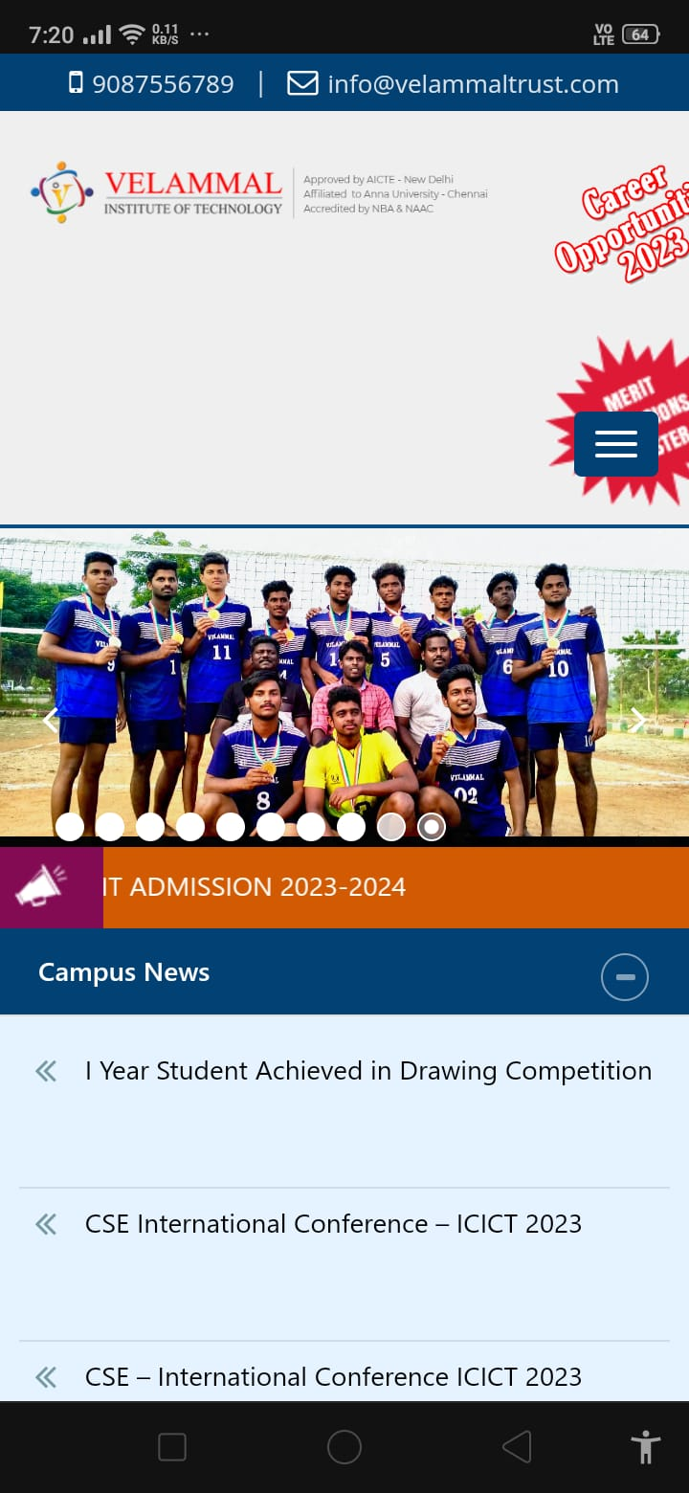

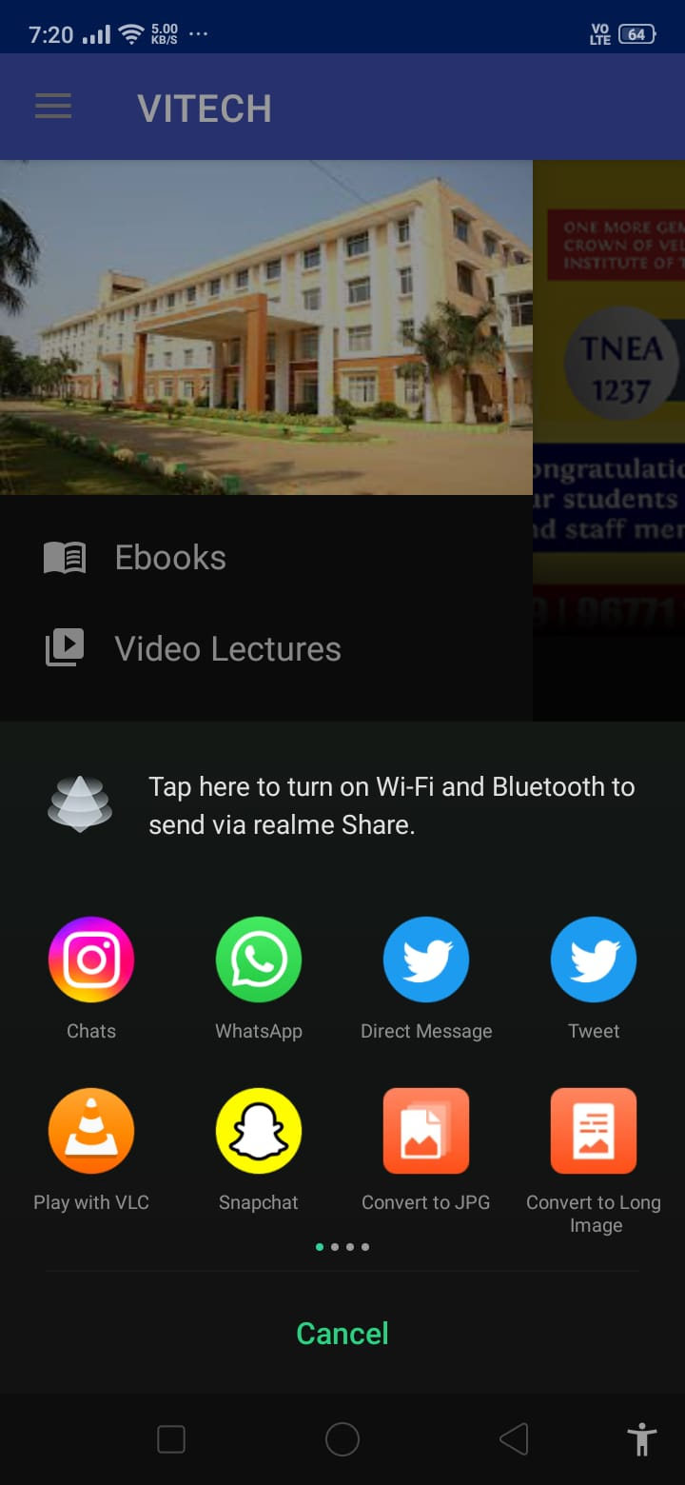

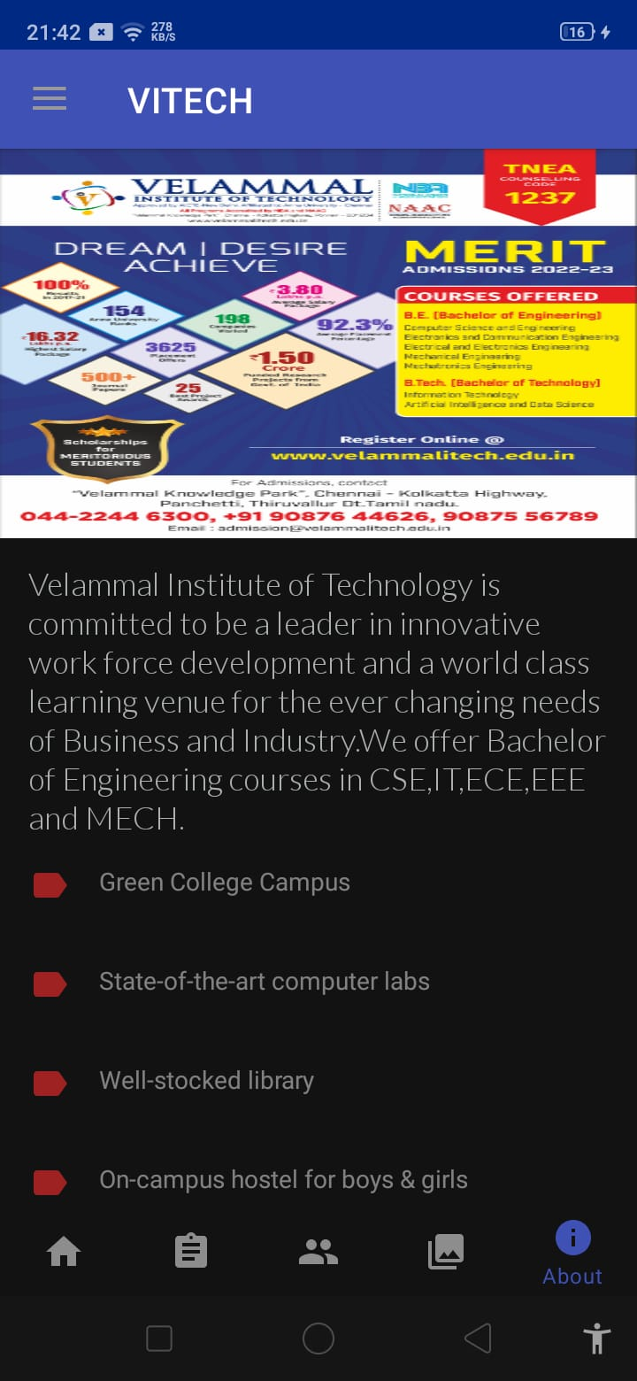

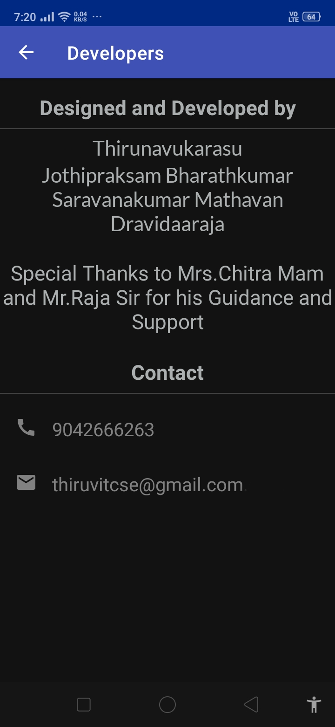

**9) REFERENCES**

**1)** https://www.geeksforgeeks.org/android-studio-tutorial/

**2**) https://firebase.google.com/

**3**) <https://www.javatpoint.com/java-apps>

**4)** https://velammalitech.edu.in/

**5**) https://www.youtube.com/@AndroidDevelopers

**6)** https://www.youtube.com/watch?v=qO1p6uLhZrM

**7)**https://www.google.com/maps/place/Velammal+Institute+of+Technology/@13.2944135,80.1467228,17z/data=!3m1!4b1!4m6!3m5!1s0x3a527efa08e09967:0xc1b057bb21ab2483!8m2!3d13.2944135!4d80.1492977!16s%2Fg%2F1thp6f74?entry=ttu

**8)** https://www.youtube.com/@velammalinstituteoftechnol242/videos

**9)** https://stucor.in/

**10)** https://www.youtube.com/@Firebase